E-COMMERCE ORDER MANAGEMENT DATABASE SYSTEM

GENERATE CUSTOMER ORDER HISTORY REPORTS

5.1 Aim
To generate customer order history and product-wise order reports using SQL queries in the ecommerce_data_base database.

5.2 Description
This task generates reports to analyze customer orders, product sales, and customer spending. SQL joins, aggregate functions, grouping, subqueries, and sorting are used to retrieve meaningful information from the database.

5.3 Reports Generated
Report 1: Customer Order History
Displays the customer name, order ID, order date, total amount, and order status. The results are arranged by order date in descending order.
Report 2: Product-Wise Order Report
Displays product ID, product name, number of orders, and total quantity sold. Cancelled orders are excluded from the calculation.
Report 3A: Customers with Maximum Orders
Identifies the customer or customers who have placed the highest number of non-cancelled orders.
Report 3B: Total Spending by Each Customer
Calculates the total spending of each customer, excluding cancelled orders. Customers without orders are also displayed.
Report 3C: Average Order Value
Calculates the average value of non-cancelled orders for each customer and displays the results in descending order.
Step 2: View All Orders
Displays all records stored in the Orders table for verification.
Step 3: View All Order Details
Displays all records stored in the Order_Details table, including product quantities and prices associated with orders.

5.4 SQL Concepts Used
- JOIN – combines data from related tables.
- COUNT() – counts the number of orders.
- SUM() – calculates total quantities and spending.
- AVG() – calculates the average order value.
- GROUP BY – groups records by customer or product.
- HAVING – filters grouped results.
- COALESCE() – handles NULL values.
- ORDER BY – sorts the report results.
- Subqueries – identify customers with the maximum number of orders.

5.5 Result
The customer order history reports were generated successfully using SQL queries. The reports provide information about customer purchases, product sales, order status, total spending, and average order value. These reports help analyze sales performance and support effective order management.

5.6 Screenshots to Attach
- Figure 5.1 – Customer Order History Report
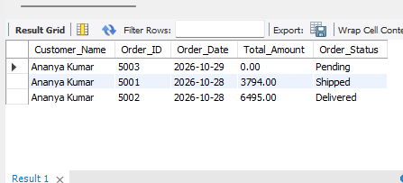
- Figure 5.2 – Product-Wise Order Report
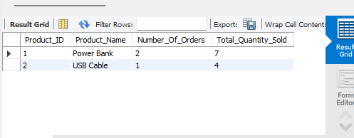
- Figure 5.3 – Customers with Maximum Orders
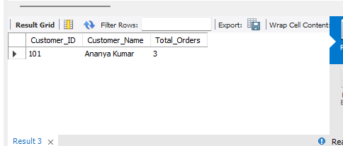
- Figure 5.4 – Total Spending by Each Customer
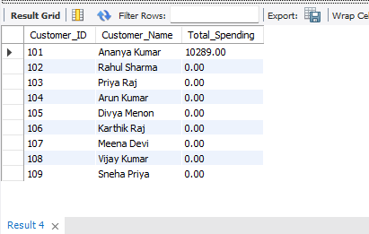

- Figure 5.5 – Average Order Value Report
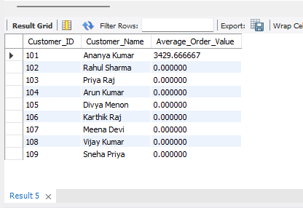
- Figure 5.6 – Displaying All Orders
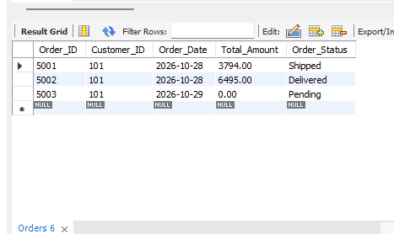
- Figure 5.7 – Displaying All Order Details
